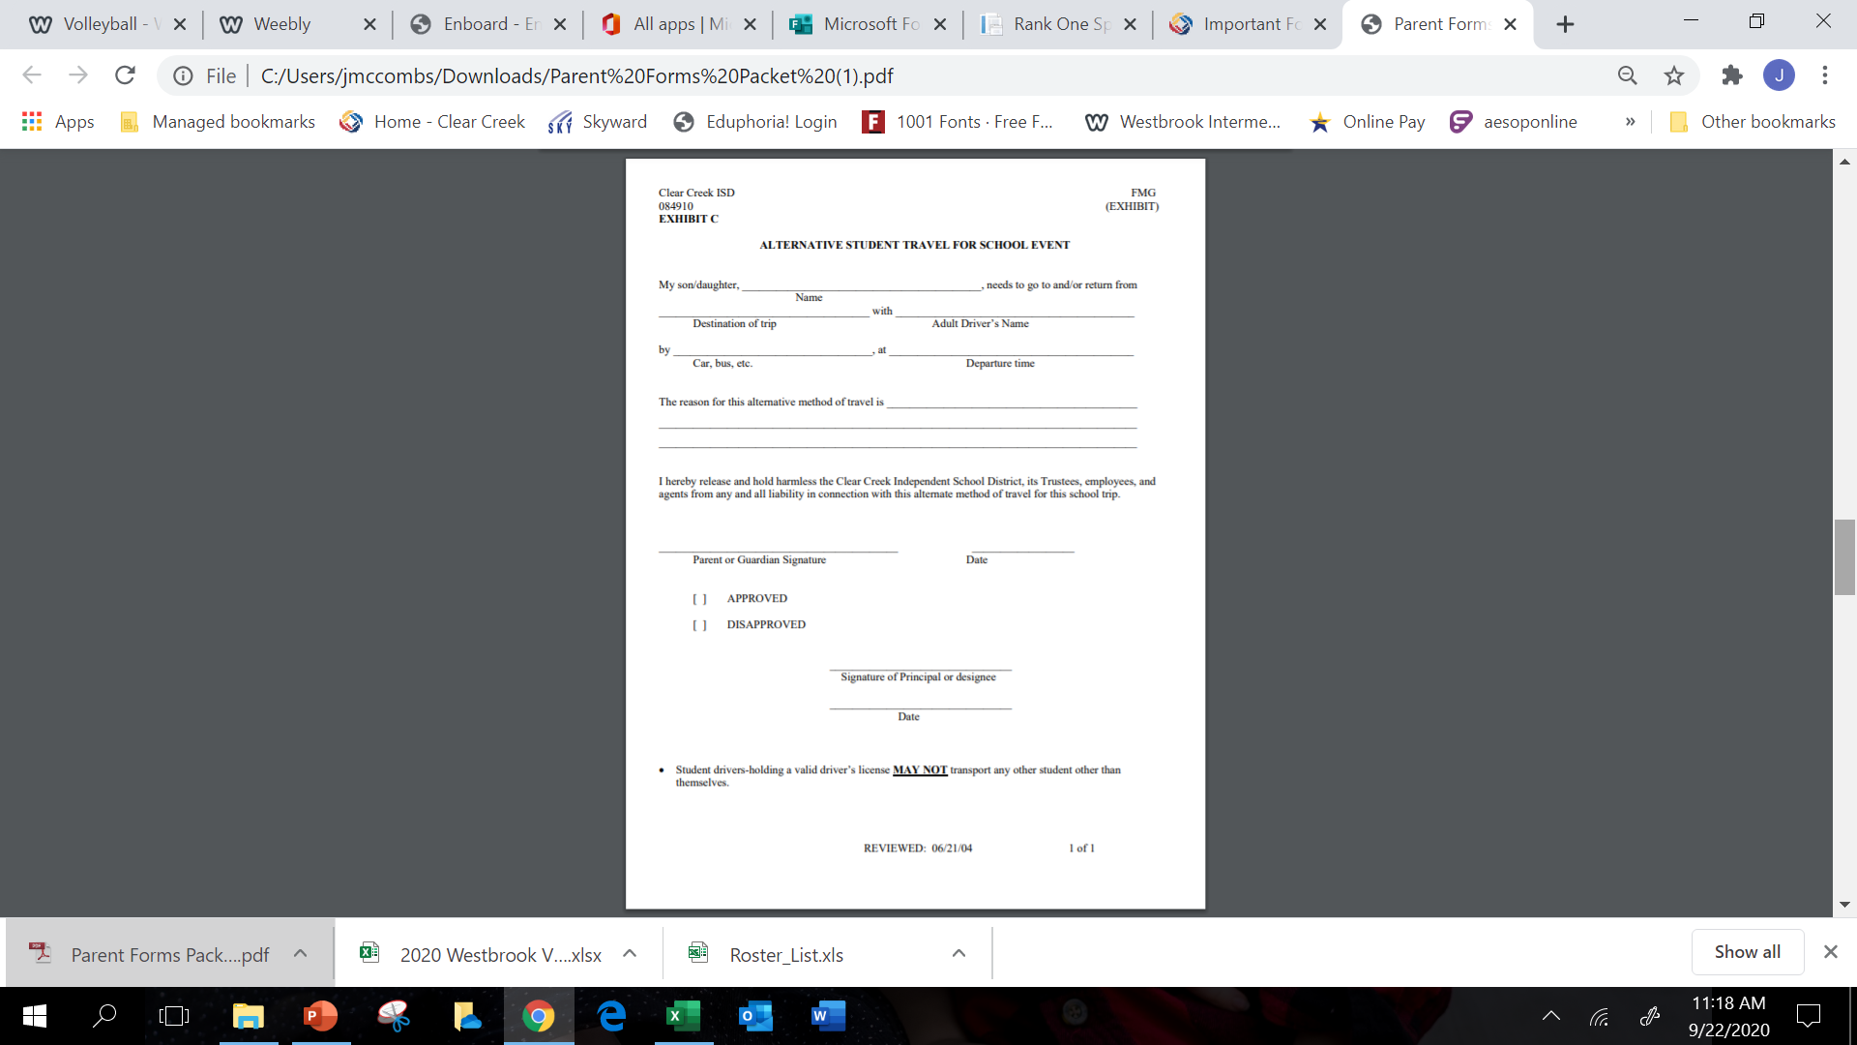

Any adult driver taking your daughter home

University of Houston tennis match

After their tennis match

Tennis Match

ATHLETE’S NAME

BUS